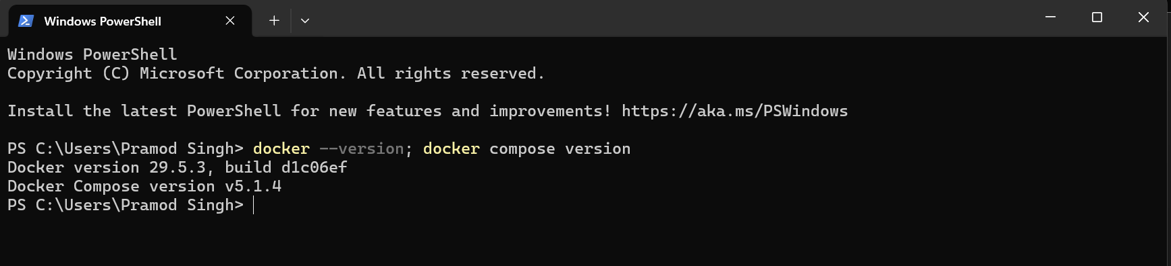

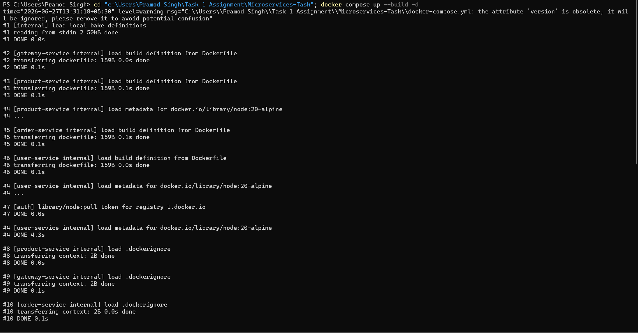

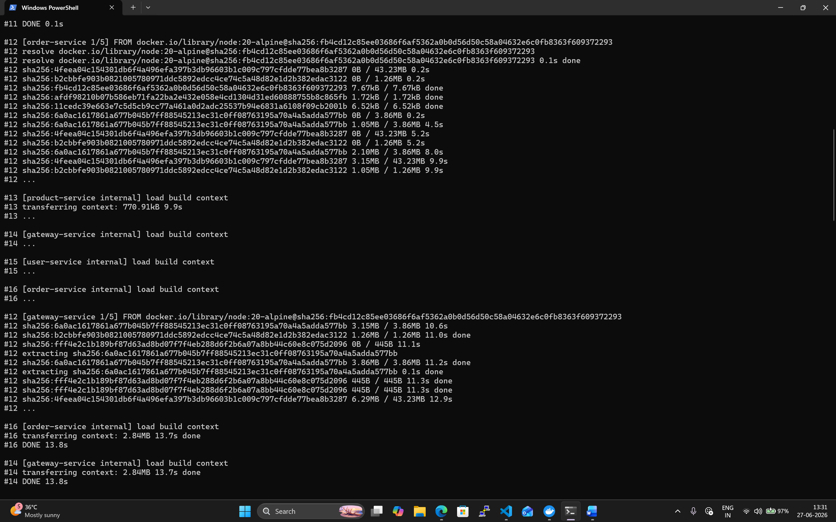

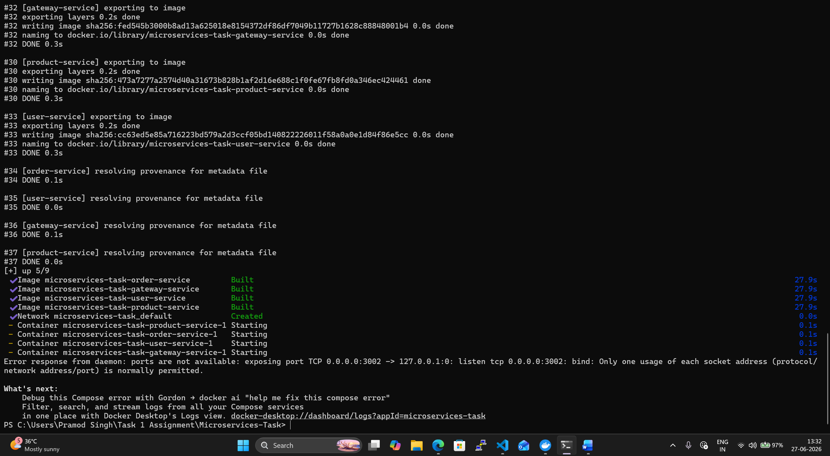

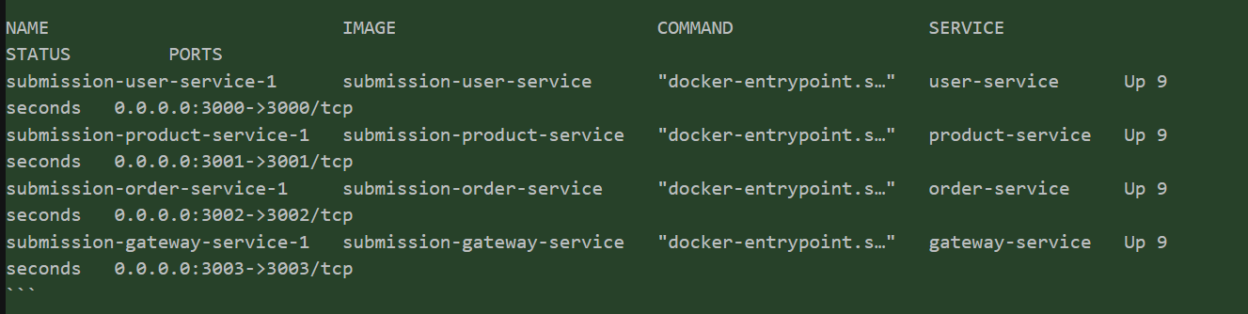

localhost:3000/users
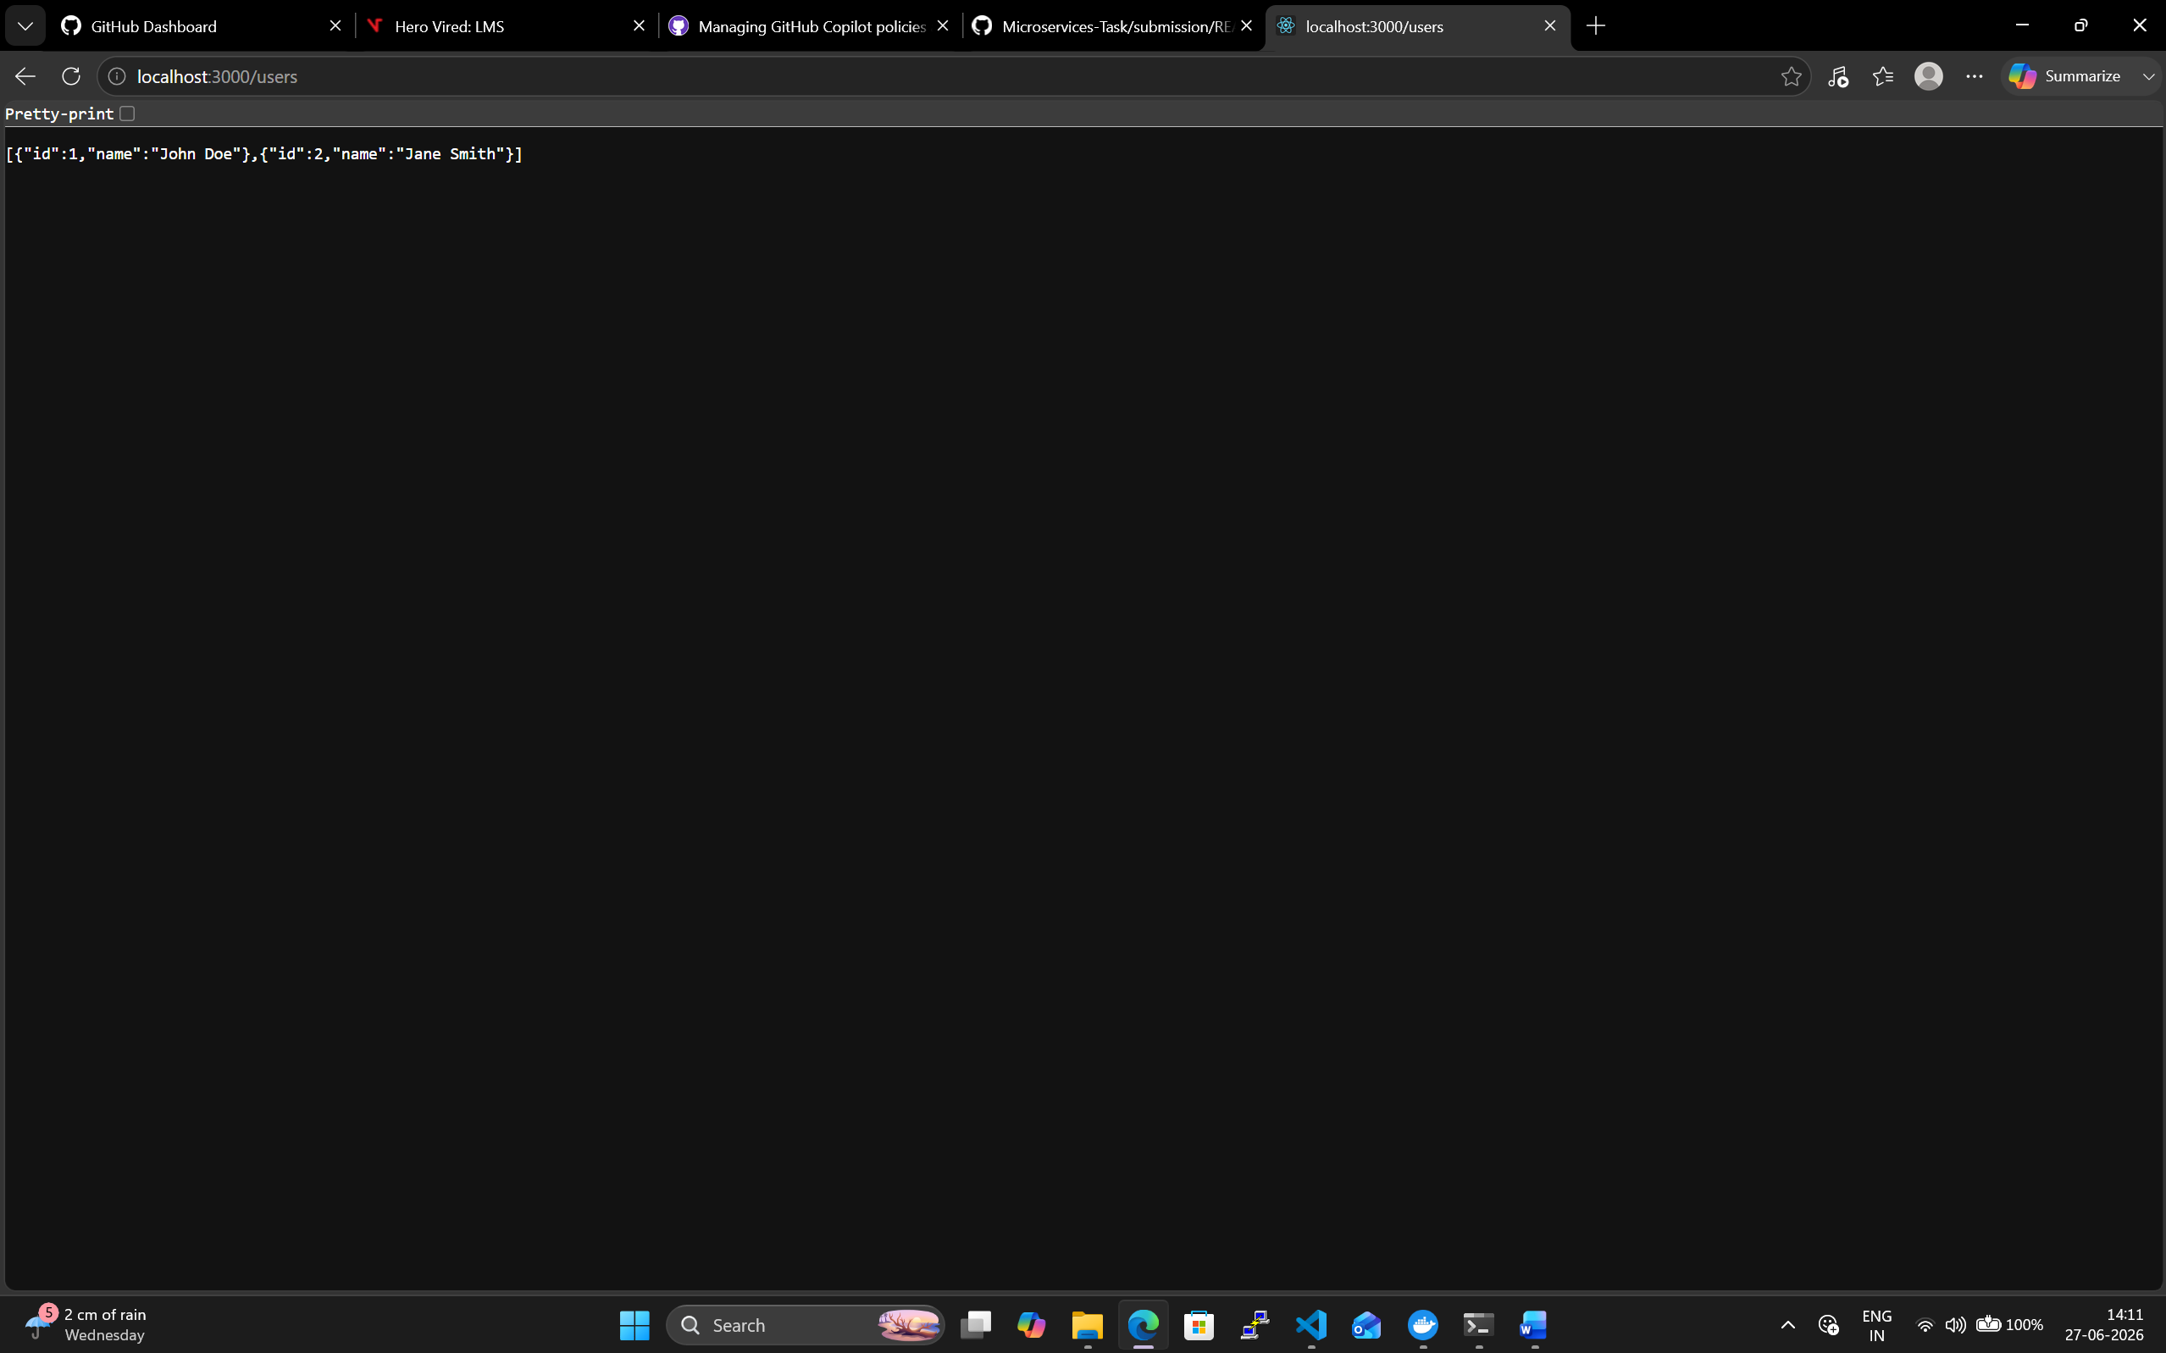

localhost:3001/products
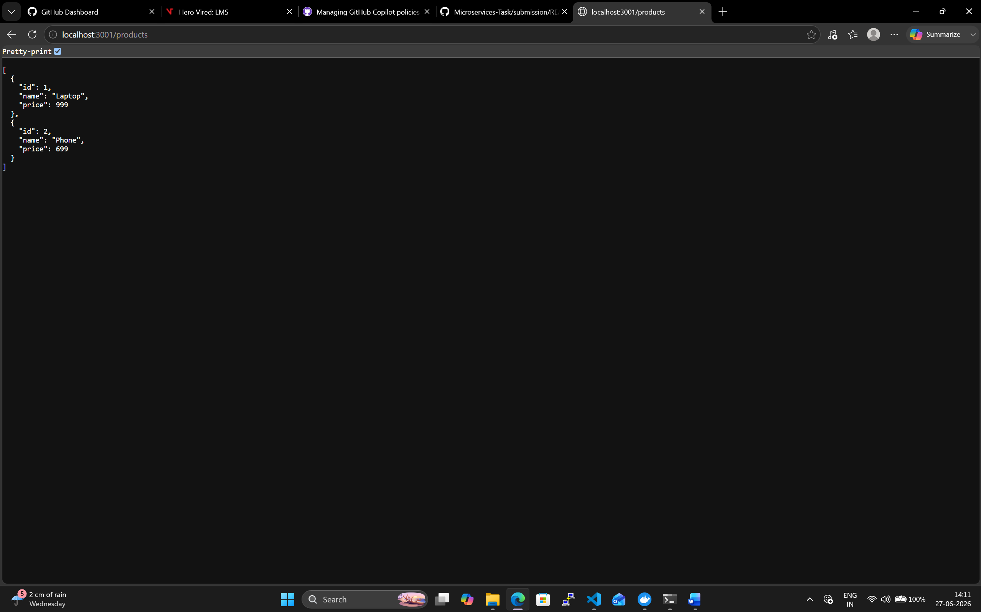

- http://localhost:3002/orders
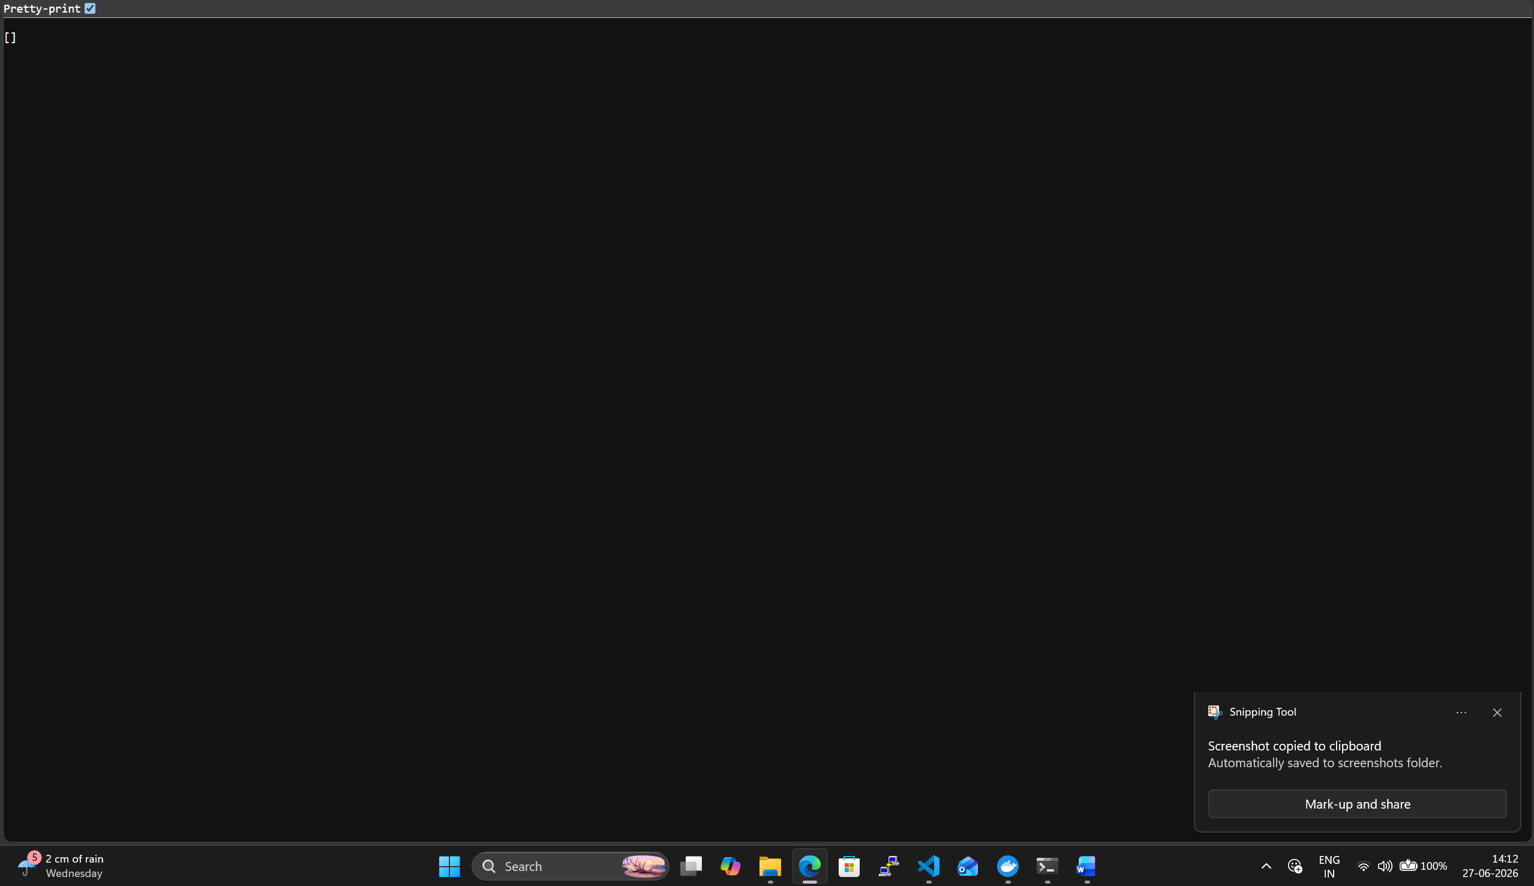

localhost:3003/api/users

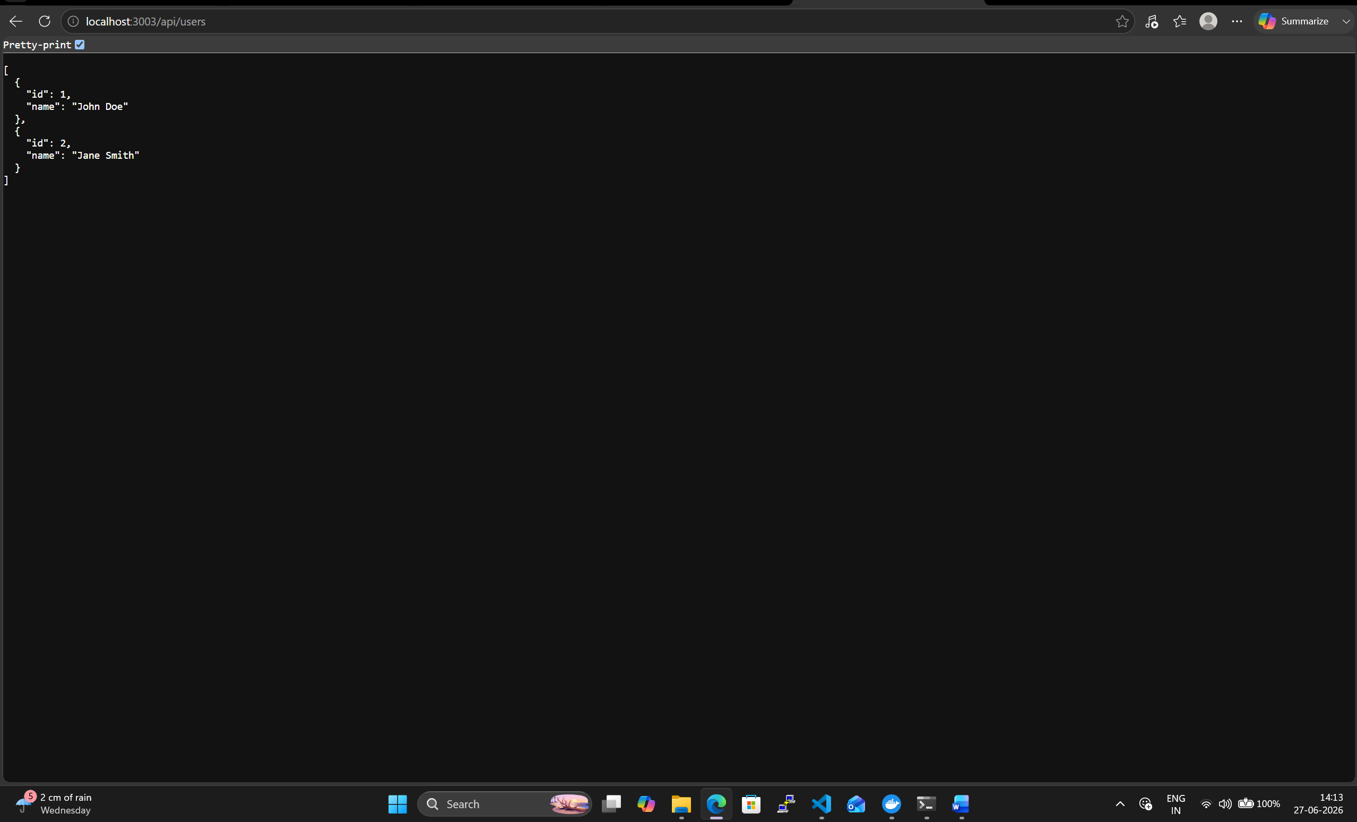
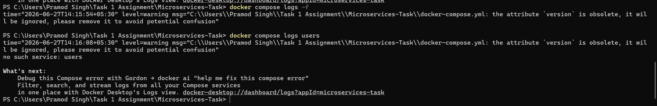

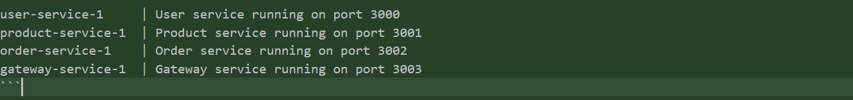
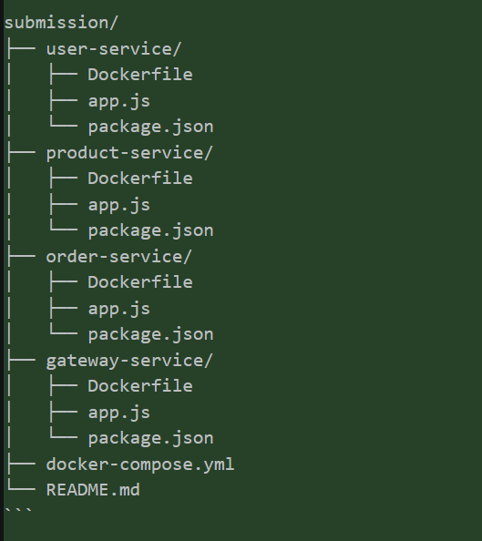

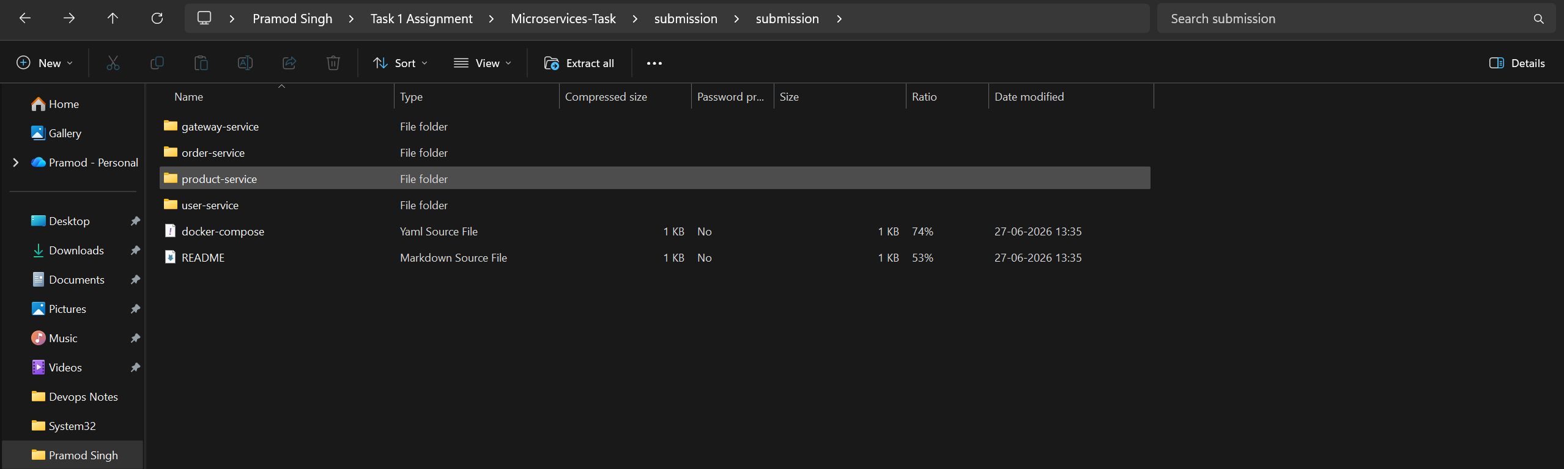

Docker file content
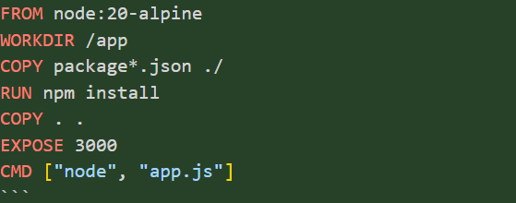

Docker compose .yamal

version: '3.8'

services:
user-service:
build:
context: ./Microservices/user-service
ports:
- "3000:3000"
environment:
PORT: 3000

product-service:
build:
context: ./Microservices/product-service
ports:
- "3001:3001"
environment:
PORT: 3001

order-service:
build:
context: ./Microservices/order-service
ports:
- "3002:3002"
environment:
PORT: 3002

gateway-service:
build:
context: ./Microservices/gateway-service
ports:
- "3003:3003"
environment:
PORT: 3003
USER_SERVICE_URL: http://user-service:3000
PRODUCT_SERVICE_URL: http://product-service:3001
ORDER_SERVICE_URL: http://order-service:3002

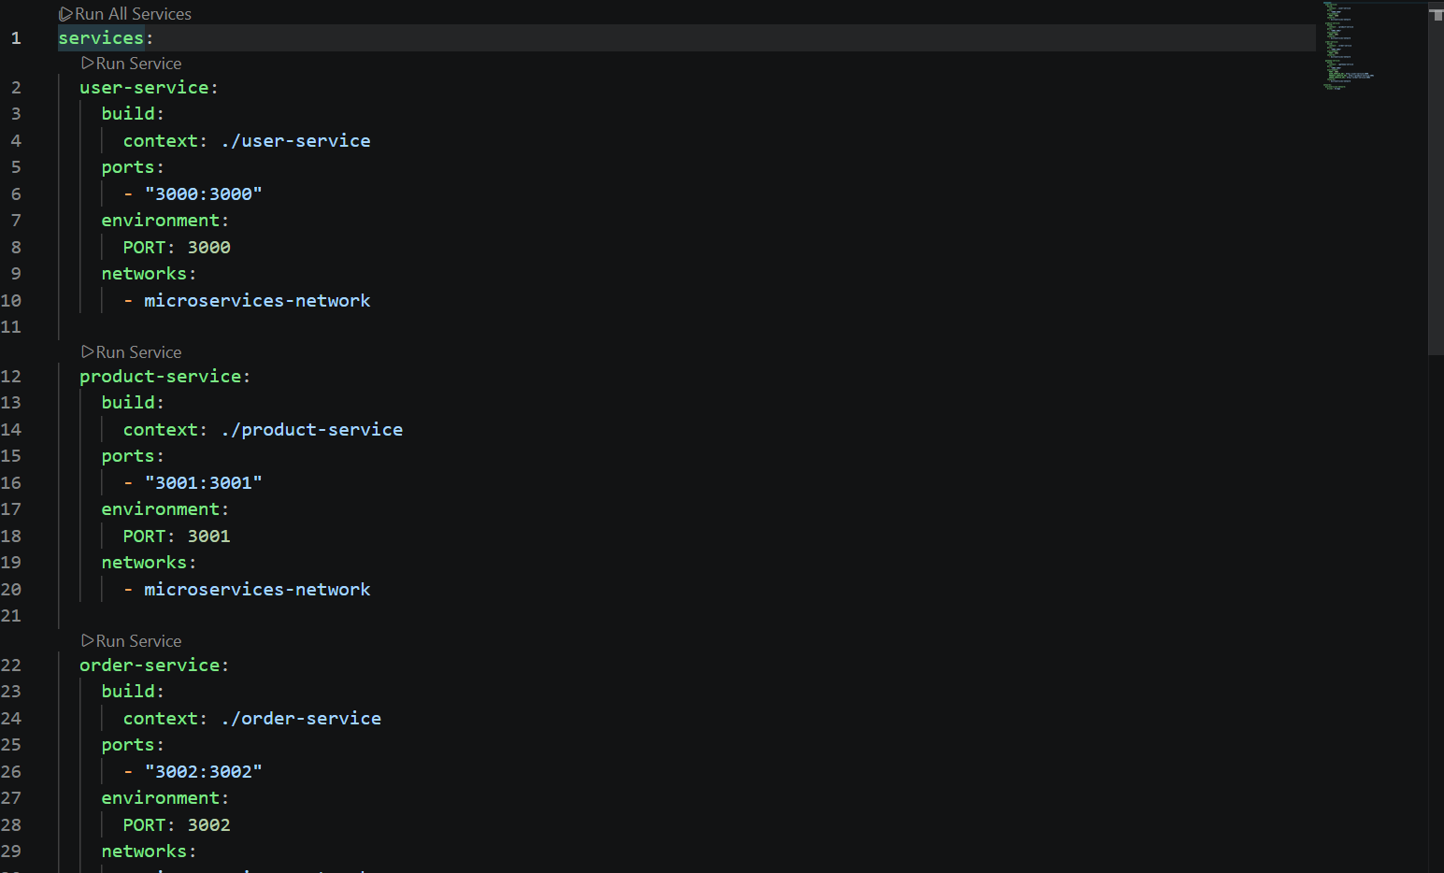

cd "c:\Users\Pramod Singh\Task 1 Assignment"
git clone https://github.com/pramod704/Microservices-Task.git
cd Microservices-Task
git add .

git commit -m "Add Docker containerization and Docker Compose orchestration

